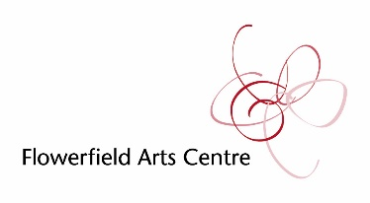
CLOSE TO HOME
MAURICE ORR
16 June – 24 July 2021

We are delighted to present a new body of work, Close to Home, by acclaimed Northern Irish artist Maurice Orr inspired by the poetry of Seamus Heaney.
Through a series of large canvasses and smaller paintings, Maurice takes the viewer on an atmospheric journey through bog, stream, lough edges, rugged fields and dramatic skies as far as the eye can see. Using earthen colours, texture, panoramic vistas and scale as tools, the viewer is enveloped by the enchantment of Ireland's rural landscape and in particular, the environment of Lough Neagh and Bellaghy which so nurtured the work of the Nobel Laureate.
The artist was born in England but grew up in Ballymena and now works from his studio based in Armoy, County Antrim. Maurice studied at the Belfast College of Art and Design in the 1970s before working as a graphic designer for the Northern Ireland Civil Service. He turned to oil painting after early retirement.
In 2002, the artist won his first international residency and in 2003 was awarded the
prestigious Arts Council of Northern Ireland’s Banff Residency in Alberta,
Canada. In 2011, he was commissioned to take part in the Cultural Olympiad
Programme, a project that culminated in a unique, multi-sensory painting
exhibition in various venues including the renowned Southbank Centre, London.
In the recent years, Maurice has been awarded residencies in Iceland, Australia and
Vancouver Island. All of these varied landscapes have featured in his work
but above all he loves the landscapes of home, never tiring of the changing
seascapes of the North Coast or the rural hedgerows and fields of County
Antrim.
“A chance visit to the Seamus Heaney Homeplace centre introduced me to a part of the world that had inspired a local boy to write the poetry which would eventually lead to a Nobel Prize for literature. I wanted to know more. Local man Eugene Kielt walked me through the area and talked about his love of Heaney’s poetry and also his love of this place. I count myself lucky to have had the chance to walk through the countryside with a man who knows it so well. The landscape that had in part inspired Heaney is at the centre of this new body of work and I’m very happy to say that I now know more about Bellaghy than I did and I’m sure that in the seasons to come I will be back.”

All artworks are for sale – please speak to our reception team with any enquiries.

www.flowerfield.org www.mauriceorr.co.uk

