The John Hewitt Society Community Bursary Award Scheme
The John Hewitt Society promotes literature, culture and the arts inspired by the Ideas and Ideals of John Hewitt, the Belfast poet, critic, curator & political thinker (1907-1987). The aim of our bursary scheme is to offer unique opportunities and experiences to encourage and foster a love of reading and to inspire, motivate, and nurture the inner writer in you.

About the Society
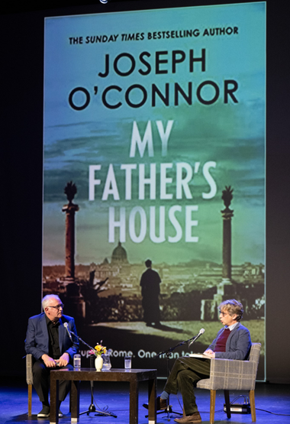
Since 1987, we have developed a wide range of literary and cultural activities to bring people of differing faith and cultural identities together in safe spaces through the medium of literature and creative writing.
The John Hewitt International Summer School, our annual Literature, & the Arts Festival, is held on the last week in July at our festival home in the Marketplace Theatre & Arts Centre, Armagh, N. Ireland.

Here audiences can hear from Poets, Authors, Artists, Speakers, Panellists from other nations, faiths and backgrounds, meet their heroes, and engage with others who share their passion for literature, books and creative writing.

Summer School offers participants neutral platforms for debate and discussion on the central issues of the day, along with opportunities to explore global views on identity, respect, tolerance & peace building towards reconciliation.
Community Bursary Awards Scheme

Applications Open: Monday 22 April 2024
Close: Thursday 9 May 2024

Thanks to the generosity of our funders and sponsors, a number of bursaries are available to help cover the cost of individual attendances during festival week. Bursary places are only open to residents from the North or South of Ireland.
…’ I can’t tell you how fantastic it was and how much of an impact attending summer school had on me. I just loved it! Thank you for the bursary.’
JHISS 2023: Bursary student

What is a Literary bursary award?
A bursary provides financial support to those, who for one reason or another, would not be able to attend the John Hewitt International Summer School. A full programme of events is on offer from 9.45am – 10.30pm, Monday – Friday, with Saturday morning workshops.
While previous bursary students have gone on to become published writers, lead workshops, invited to host live and online author events, read at poetry & writing festivals, others come back to volunteer for us each year at the JHISS, or are employed within the literary arts.

A Full Sponsored Residential bursary award includes:
- B&B for five nights in a single ensuite room, within walking distance of the venue.
- Free tickets to all programmed events, unless specified.
- Creative writing workshop course of your choice, with 6 hours free tuition over 3 days.
- Invitation to all receptions.
- Morning break refreshments.
…‘The programme was so well put together, with such talent, a diverse and stimulating range of voices. A really incredible and life-changing experience!’
‘You gave me an opportunity I've never had before, for which I am eternally grateful’

‘The diversity of the speakers and the events were of such high standard, making the week a real pleasure.’
JHISS 2023: Bursary comments

Each Bursary Award is worth £700.00.

A limited number of daily half bursaries (non-residential) are available for those who may have personal or other circumstances that do not permit them to spend evenings away from home.

How to apply for a bursary award?
Online at our website johnhewittsociety.org/
If you require a hard copy, just let us know.

ONLINE Applications Open: Monday 22 April 2024
Close: Thursday 9 May 2024

How is it assessed?
Assessment criteria is as follows:
- First time applicants*
- Residency**
- Unwaged, in receipt of benefits or part-time (16 hrs).
- Evidence of an interest in the ethos of the John Hewitt Summer School.
- Evidence of how your experience could impact your local community.

* Previous applicants may re-apply, but priority goes to those who have never attended.
Due to demand for places, residential award holders for the JHISS23 are not eligible.
** Bursaries funded by local councils are awarded to those who live within those designated council postcode areas only.
A small number of full and half bursary places are also available to ABC Council & ROI residents.

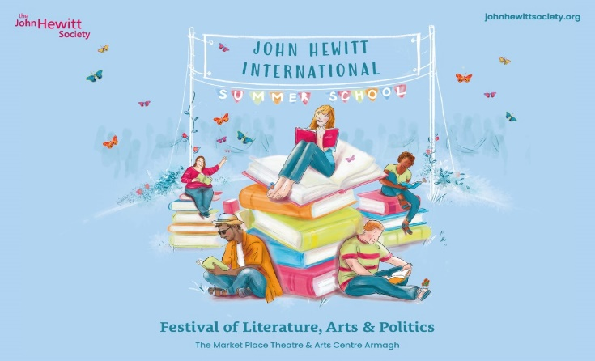
Any queries, please contact us at…
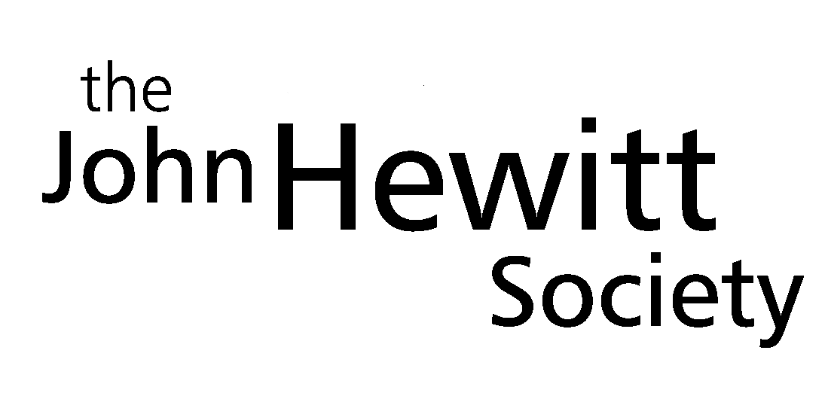

The MAC Arts Centre – Level 3
10 Exchange Street West
Belfast. BT1 2NJ.

Email: project@johnhewittsociety.org
Office: 028 9032 4522
Website johnhewittsociety.org

